

Business Analytics

Chapter 6 Statistical Inference

4



Statistical Inference

If we want to know something about a population, why can’t we just ask everyone?

* We can:
  + With - A Census
    - collects data from every element in the population of interest
* We can’t always ask everyone though:
  + Expensive.
  + Time consuming.
  + Misleading.
  + Unnecessary.
  + Impractical.

5



Statistical Inference

* **Statistical inference**
  + Uses sample data to make estimates of or draw conclusions about one or more characteristics of a population.
* The **sampled population**
  + is the population from which the sample is drawn.
* A **frame**
  + is a list of elements from which the sample will be selected.

6

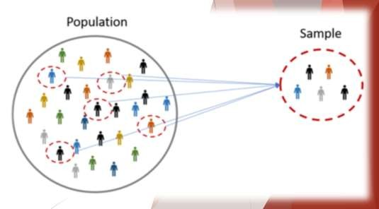

Sampling Examples



# Election Year!

* + Texas members of a political party are considering supporting a candidate
  + Need to estimate the proportion of voters that favor the candidate in Texas
  + Of 400 voters, 160 prefer the candidate = 40%

Sample Population: Registered voters in Texas (Finite)

Frame: List of all the voters

Sample Population: All the tires that could have been made (Infinite)

Frame: None

# New Tires

* + Tire company makes a new tire that is supposed to have increased life on the roads
  + Makes 120 tires for testing
  + Mean of 36,500 miles

7



Selecting a Sample

Sampling from a Finite Population Sampling from an Infinite Population

8



Selecting a Sample

* **Parameter**:
  + A measurable factor that defines a characteristic of a population, process, or system.
    - Examples: Population: Mean, Standard Deviation, Correlation, Variance
* Sampling from a Finite Population:
  + make valid statistical inferences about the population.
* Simple Random Sample (Finite Population):
  + A **simple random sample** of size *n* from a finite population of size *N*
  + is a sample selected such that each possible sample of size *n* has the same probability of being selected.

9



Selecting a Sample

Figure 6.1: Using Excel to Select a Simple Random Sample

10

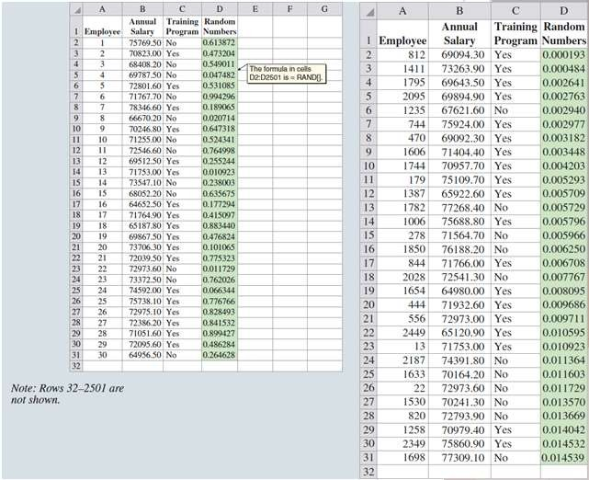

Selecting a Sample

* Sampling from an Infinite Population:
  + With an infinite population, you cannot select a simple random sample because you cannot construct a frame consisting of all the elements.
  + Statisticians recommend selecting what is called a random sample.
  + Usually associated with a process that operates over time.
    - An ongoing process
* Random Sample (Infinite Population):
  + A **random sample** of size *n* from an infinite population is a sample selected such that the following conditions are satisfied:

1. Each element selected comes from the same population.

2. Each element is selected independently.

11



Point Estimation

12



Point Estimation

* Sample **statistic**
  + An estimate for a population parameter

The sample mean 𝑥 is the **point estimator** of the population mean 𝜇

The sample standard deviation 𝑠 is **the point estimator** of the population standard deviation 𝜎. The sample proportion 𝑝 is the **point estimator** of the population proportion 𝑝.

The numerical value obtained for 𝑥, 𝑠, or 𝑝 is called the **point estimate.**

|  |  |  |
| --- | --- | --- |
|  | **Population** | **Sample** |
| Mean | 𝜇 | 𝑥 |
| Standard Deviation | 𝜎 | s |
| Proportion | 𝑝 | 𝑝 |

13



Point Estimation

Annual Salary and Training Program Status for a Simple Random Sample of 30 EAI Employees (Excel)

14

